Object-Oriented PHP Implementation for Car Dealership Management System

An Assignment submitted in partial fulfillment of the requirements for the degree of
Bachelor of Science
in
Computer Science

CS 3305: Web Programming 2

Term 4 - 2025
University of The People

Instructor: Shobhit Mani Tewari

May 14 2026

Object-Oriented Programming in PHP: Car Dealership Vehicle Management System
The development of a car dealership vehicle management system demonstrates the practical application of object-oriented programming (OOP) principles in PHP. This implementation leverages inheritance, encapsulation, and polymorphism to create a robust, maintainable system for managing diverse vehicle types while maintaining code reusability and logical organization.
The foundation of this system is the Vehicle base class, which serves as the parent class for all vehicle types. According to McGrath (2021), base classes should contain common attributes and methods that will be inherited by child classes. The Vehicle class includes essential properties such as $brand, $model, $year, and $price, which are universal across all vehicle types. Additionally, the class implements a static property $count to track the total number of vehicle instances created, demonstrating the use of static members for class-level data management. The Vehicle class provides core functionality through its displayInfo() method, which outputs common vehicle details. This method demonstrates polymorphism as it will be overridden by subclasses to provide specific implementations while maintaining a consistent interface. Furthermore, the compareVehicles() method enables object comparison based on different criteria such as price or year, showcasing the implementation of business logic within classes.
// Attributes in the parent class
<?php
class Vehicle
{
public string $brand;
public string $model;
public int $year;
public float $price;
public static int $count = 0;
public function __construct($brand, $model, $year, $price)
{
$this->brand = $brand;
$this->model = $model;
$this->year = $year;
$this->price = $price;
self::$count++;
}
// Methods in the parent class
public function displayInfo() : void
{
echo "<div class='vehicle-info'>";
echo "<h3>Vehicle Information</h3>";
echo "<p><strong>Brand:</strong> " . htmlspecialchars($this->brand, ENT_QUOTES, 'UTF-8') . "</p>";
echo "<p><strong>Model:</strong> " . htmlspecialchars($this->model, ENT_QUOTES, 'UTF-8') . "</p>";
echo "<p><strong>Year:</strong> " . $this->year . "</p>";
echo "<p><strong>Price:</strong> $" . number_format($this->price, 2) . "</p>";
echo "</div>";
}
public function compareVehicles($otherVehicle, $criterion) : string
{
switch ($criterion) {
case 'price':
if ($this->price > $otherVehicle->price) {
return $this->brand . " " . $this->model . " is more expensive by $" . number_format($this->price - $otherVehicle->price, 2);
} elseif ($this->price < $otherVehicle->price) {
return $this->brand . " " . $this->model . " is cheaper by $" . number_format($otherVehicle->price - $this->price, 2);
} else {
return "Both vehicles have the same price";
}
break;
case 'year':
if ($this->year > $otherVehicle->year) {
return $this->brand . " " . $this->model . " is newer by " . ($this->year - $otherVehicle->year) . " years";
} elseif ($this->year < $otherVehicle->year) {
return $this->brand . " " . $this->model . " is older by " . ($otherVehicle->year - $this->year) . " years";
} else {
return "Both vehicles are from the same year";
}
break;
default:
return "Invalid comparison criterion. Use 'price' or 'year'.";
}
}
public static function getTotalVehicles() : int
{
return self::$count;
}

Inheritance is implemented through three subclasses: Car, Truck, and Motorcycle. Each of these subclasses begins by including the parent Vehicle class using require_once 'Vehicle.php', ensuring that the base class definition is available before the child classes are declared (McGrath, 2021). This allows each subclass to extend the Vehicle class, inheriting its properties and methods while adding unique characteristics specific to their category. The Car class includes $numberOfDoors, the Truck class incorporates $cargoCapacity, and the Motorcycle class features $handlebarType. This design follows the principle of specialization, where child classes extend parent functionality with domain-specific attributes.
<?php
require_once 'Vehicle.php';
class Car extends Vehicle
{
public int $numberOfDoors;
public function __construct($brand, $model, $year, $price, $numberOfDoors)
{
parent::__construct($brand, $model, $year, $price);
$this->numberOfDoors = $numberOfDoors;
}
}

<?php
require_once 'Vehicle.php';
class Truck extends Vehicle
{
public int $cargoCapacity;
public function __construct($brand, $model, $year, $price, $cargoCapacity)
{
parent::__construct($brand, $model, $year, $price);
$this->cargoCapacity = $cargoCapacity;
}

<?php
require_once 'Vehicle.php';
class Motorcycle extends Vehicle
{
public string $handlebarType;
public function __construct($brand, $model, $year, $price, $handlebarType)
{
parent::__construct($brand, $model, $year, $price);
$this->handlebarType = $handlebarType;
}
Method overriding is demonstrated through the reimplementation of displayInfo() in each subclass. While the base class provides a generic display method, each subclass overrides it to display both common and specific details relevant to that vehicle type. This polymorphic behavior allows the system to treat all vehicles uniformly while providing specialized output when appropriate (Martinez et al., 2019). The user interface is implemented through an HTML form that collects vehicle details and dynamically adjusts input fields based on the selected vehicle type. This form processing demonstrates the separation of concerns between presentation (HTML/CSS) and business logic (PHP classes). The form handler processes user input, instantiates appropriate objects, and manages session data to maintain state across page requests.
// Car displayInfo() logic

public function displayInfo() : void
{
echo "<div class='vehicle-info car-info'>";
echo "<h3>Car Information</h3>";
echo "<p><strong>Brand:</strong> " . htmlspecialchars($this->brand, ENT_QUOTES, 'UTF-8') . "</p>";
echo "<p><strong>Model:</strong> " . htmlspecialchars($this->model, ENT_QUOTES, 'UTF-8') . "</p>";
echo "<p><strong>Year:</strong> " . $this->year . "</p>";
echo "<p><strong>Price:</strong> $" . number_format($this->price, 2) . "</p>";
echo "<p><strong>Number of Doors:</strong> " . $this->numberOfDoors . "</p>";
echo "</div>";
}

// Truck displayInfo() logic

public function displayInfo() : void
{
echo "<div class='vehicle-info truck-info'>";
echo "<h3>Truck Information</h3>";
echo "<p><strong>Brand:</strong> " . htmlspecialchars($this->brand) . "</p>";
echo "<p><strong>Model:</strong> " . htmlspecialchars($this->model) . "</p>";
echo "<p><strong>Year:</strong> " . $this->year . "</p>";
echo "<p><strong>Price:</strong> $" . number_format($this->price, 2) . "</p>";
echo "<p><strong>Cargo Capacity:</strong> " . $this->cargoCapacity . " cubic feet</p>";
echo "</div>";
}

// MotorVehicle displayInfo() logic

public function displayInfo() : void
{
echo "<div class='vehicle-info motorcycle-info'>";
echo "<h3>Motorcycle Information</h3>";
echo "<p><strong>Brand:</strong> " . htmlspecialchars($this->brand) . "</p>";
echo "<p><strong>Model:</strong> " . htmlspecialchars($this->model) . "</p>";
echo "<p><strong>Year:</strong> " . $this->year . "</p>";
echo "<p><strong>Price:</strong> $" . number_format($this->price, 2) . "</p>";
echo "<p><strong>Handlebar Type:</strong> " . htmlspecialchars($this->handlebarType) . "</p>";
echo "</div>";
}

The system incorporates several key OOP concepts, including encapsulation through private/protected properties, inheritance through class extension, polymorphism through method overriding, and abstraction through consistent interfaces (Martinez et al., 2019). The static counter demonstrates class-level functionality, while the comparison method shows how objects can interact with each other through defined methods. This implementation effectively models a real-world scenario using object-oriented principles, creating a scalable and maintainable solution for vehicle management. The separation of concerns, use of inheritance hierarchies, and implementation of polymorphic behavior demonstrate best practices in PHP OOP development.
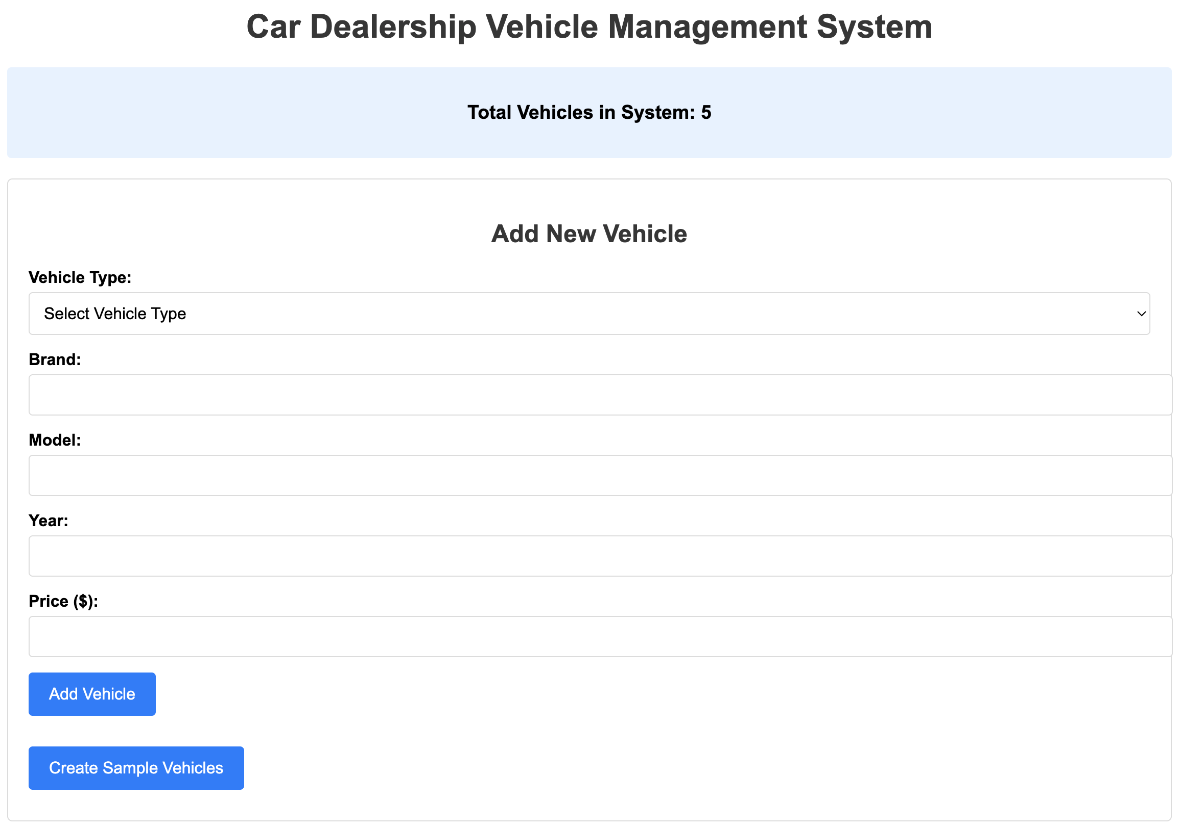

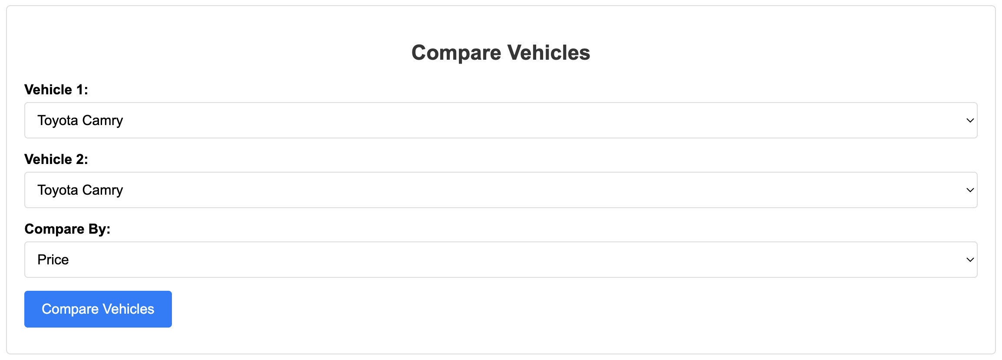

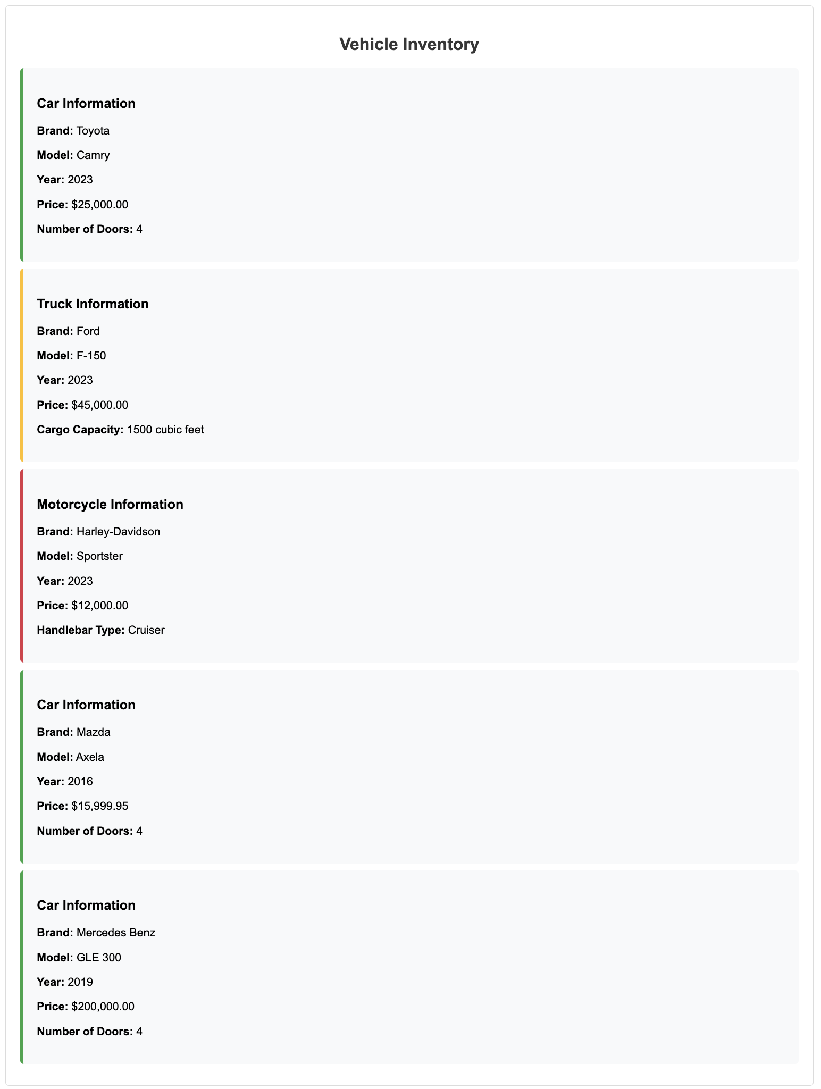
References
Martinez, J., et al. (2019). The PHP workshop: Learn to build interactive applications and kickstart your career as a web developer. Packt Publishing, Limited.
McGrath, M. (2021). PHP in easy steps (4th ed.): Updated for PHP 8. In Easy Steps Limited.

